EEG Processing Basics

Raw data or primary data is the data collected from the source. In EEG, the scalp potentials are acquired.

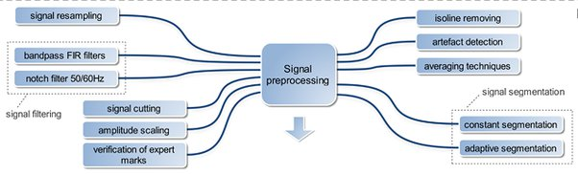

Like any kid, the story of raw data processing happens before its birth. Some hardware-level processing involves frequency band-pass filtering, which kills the age-old villain 50/60 Hz.

Now we have other minor but very gory villains to slay. Let me introduce them one by one:

1. **Blinking artifact**

Humans are supposed to close their eyes or never close their eyes. The blinking of the eye creates a spike in the EEG signal. And no one should swallow or grin their teeth thinking, WTF is the researcher doing? There are plenty of eye-blink removal filters available in the market. Use them thrice a day.

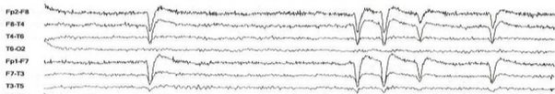

1. **Electrical signals (uninvited) guests from other places**

ECG signals, muscle activity, and electrical noise from other equipment in the recording room. People with short necks produce more ECG artefacts. We can eliminate this if we have another electrode for recording ECG, find this culprit in EEG, and kill him using the famous "that should not be named" algorithm. Pulse artefacts are slow and smooth curves.

https://qph.cf2.quoracdn.net/main-qimg-436acd162b7398642073091f2398be7b

1. **Electrode effects**

Meh, falling electrodes (which happens when the subject is female) are due to oil in the hair (Don't include Kerala girls in your EEG study; their long, oily hair corrupts the EEG and the researcher's mind). If the electrode moves, the EEG will display

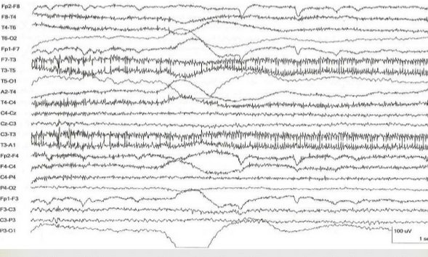

**4. The cocktail party problem**

Assume we have ten sources (speakers) that produce these oscillations. EEG is like a single audio recorder that records all these ten speeches. We can separate these ten speakers using ICA (independent component analysis) algorithms.

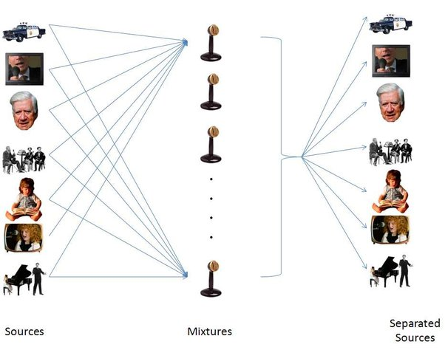

**TOOLS TO HANDLE THESE ISSUES**

* **EEGLAB, ERPLAB**

These are free plugins in MATLAB and have fantastic potential for artefact correction.

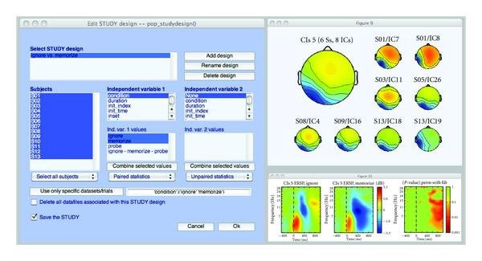

* [Introduction - Brainstorm](http://neuroimage.usc.edu/brainstorm/)

